Lesson 9: How do other contact forces from interactions with the air and the track cause energy transfers in the launcher system?

Previous Lesson | We developed a model to show where energy is transferred between the spring, cart, and box and how contact forces cause this energy transfer. We used this to start brainstorming other places where contact forces may be causing energy transfer in the system.
This Lesson  Investigation  2 days   | 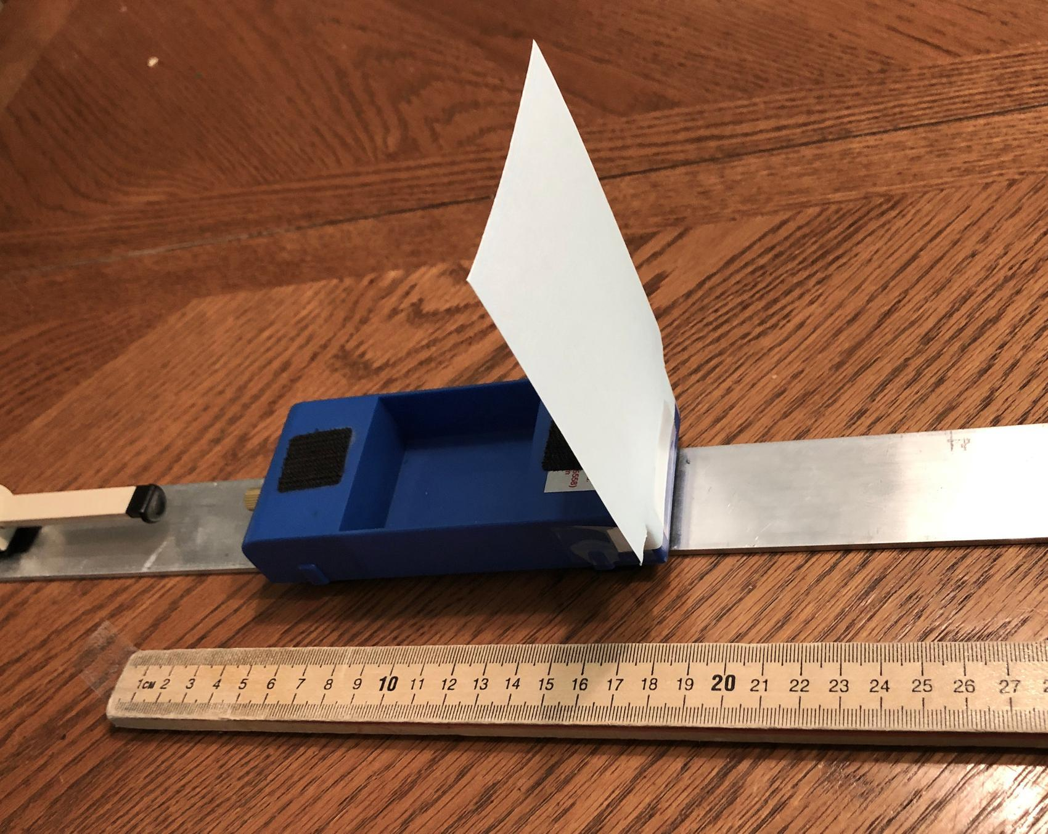 | We conduct investigations to gather evidence to explain what other forces affect the kinetic energy of an object before a collision. We develop claims using our evidence and provide and receive feedback with peers to synthesize our ideas. We revise our model to show additional places in the launcher system where energy is transferred and how contact forces cause this energy transfer.
Next Lesson | We will revisit the Lesson 1 collision types and explain why some objects were damaged when others were not in different collisions. We will use these ideas to answer questions on the Driving Question Board and take an assessment to apply our new ideas to a new set of collision-related phenomena in the context of baseball.

BUILDING TOWARD NGSS  MS-PS2-1, MS-PS2-2, MS-PS3-1, MS-ETS1-2, MS-ETS1-3, MS-LS1-8   | What students will do  9.A Apply scientific ideas and evidence to construct an explanation for the causes of motion and kinetic energy changes that happen before and after collisions and how these affect the outcome of a collision.  9.B Respectfully provide and receive critiques about claims to identify relevant evidence to support an explanation for how energy transfers through the cart-launcher system before and right after a collision.  9.C Develop and revise a model to identify other parts of the system the cart and box are making contact with or colliding into that are producing contact forces on these subsystems, causing energy to be transferred to or from them as the box and cart travel down the track.  What students will figure out  - Friction is a contact force due to interaction between surfaces in contact and is produced by the bumps (roughness) on surfaces as they push against each other.  - Interactions due to friction and air resistance apply contact forces to a moving object that are in a direction that is opposite its motion.  - Force interactions due to friction and air resistance transfer energy to the surfaces of the objects that slide over each other; this results in an increase in particle-level kinetic energy (a temperature increase).  - Energy can be transferred to and from collisions between objects and particles in the air.

Lesson 9 • Learning Plan Snapshot
Part | Duration |  | Summary | Slide | Materials
1 | 5 min |  | SHARING RESULTS FROM OUR HOME LEARNING INVESTIGATION  Discuss observations from home learning investigations assigned at the end of Lesson 8. | A | Investigating Surface Interactions, Investigating Interactions with the Air, optional: 1 shoe, optional: 1 rubber band, optional: 1 carpet square, optional: 4 index cards
2 | 5 min |  | NAVIGATION  Recollect ideas about how speed and mass both affect the kinetic energy of an object. | B | Investigating Surface Interactions, Investigating Interactions with the Air
3 | 25 min |  | CONDUCTING INVESTIGATIONS: OTHER FORCES IN OUR COLLISION SYSTEM  Conduct station investigations to explore other forces in a collision system. | C | Divide into Stations: Other Forces in Our Collision System Investigation
4 | 10 min |  | CONSTRUCT AN EVIDENCE-BASED EXPLANATION  Construct explanations for investigations done at the stations. | D | blank sheet of paper (optional)

End of day 1
5 | 5 min |  | NAVIGATION  Connect to previous explanations of each investigation station. | E
6 | 22 min |  | JIGSAW FEEDBACK GROUP DISCUSSION  Present and defend explanations for the cause-effect relationships for the motion and kinetic energy changes in the launcher system. | F-G | Jigsaw feedback discussion
7 | 14 min |  | REVISE OUR MODEL  Gather in the Scientists Circle to revise our collision system model and describe motion and KE changes that result from friction and collisions with air particles. | H-I | Energy transfers and contact forces in the launcher, cart, track, and box system, colored pencils, Energy transfers and contact forces in the launcher, Lesson 8 cart/box/track system poster
8 | 4 min |  | NAVIGATION  Introduce home learning. | J | Modeling other force interactions in the launcher, cart, box, and track system, colored pencils, Key for modeling force interactions in the launcher, cart, box, and track system

End of day 2

Lesson 9 • Materials List
 | per student | per group | per class
Divide into Stations: Other Forces in Our Collision System Investigation materials | - Data collection from stations |  | - 1 aluminum bar track (3 ft x 1.5 in x ⅛ in)  - 2 carts  - 1 index card taped to cart  - painters tape  - 1 timer  - 1 fan  - 1 meter stick  - Station 2 data cards  - 1 large rubber eraser  - 1 Styrofoam takeout container  - 1 infrared thermometer  - 2 copies of Lab station instructions  - Microscopic image cards  - computer  - https://www.openscied.org/friction-simulation/
Lesson materials | - Investigating Surface Interactions  - Investigating Interactions with the Air  - science notebook  - blank sheet of paper (optional)  - Jigsaw feedback discussion  - Energy transfers and contact forces in the launcher, cart, track, and box system  - colored pencils  - Modeling other force interactions in the launcher, cart, box, and track system |  | - optional: 1 shoe  - optional: 1 rubber band  - optional: 1 carpet square  - optional: 4 index cards  - Energy transfers and contact forces in the launcher  - Lesson 8 cart/box/track system poster  - Key for modeling force interactions in the launcher, cart, box, and track system

Materials preparation (60 minutes)

Review teacher guide, slides, and teacher references or keys (if applicable).

Make copies of handouts and ensure sufficient copies of student references, readings, and procedures are available.

Modify slide F to replace it with the classroom norms your classes developed, if they are different than those shown on the slide.

Be prepared to distribute the completed copies of Modeling other force interactions in the launcher, cart, box, and track system you collected and copied from last time.

Have the Energy transfers and contact forces in the launcher, cart, box, and track system poster from the last lesson along corresponding sticky note annotations added to it from the last lesson.

Test the simulation link to make sure it is working: https://www.openscied.org/friction-simulation/

Day 1: Other Forces in Our Collision System Investigation
- Group size: 3-4 students
- Setup: Gather materials for 8 stations, 2 each of the following 4 stations:
- Materials for station 1
- 1 aluminum bar track (3 ft x 1.5 in x ⅛ in)
- 2 carts
- 1 index card attached with transparent tape to 1 cart
- 1 small fan
- 4 6-inch pieces of painters tape to secure track
- 1 timer
- 1 meter stick
- Materials for station 2
- Station 2 data cards
- Materials for station 3
- 1 large rubber eraser
- 1 Styrofoam takeout food container broken into 2 pieces
- 1 infrared thermometer
- Materials for station 4
- Microscopic image cards
- 1 computer or tablet with access to https://www.openscied.org/friction-simulation/
- Make single-sided copies of station handouts:
- 2 copies of Lab station instructions
- 2 copies of Station 2 data cards
- 2 copies of Microscopic image cards
- Safety:
- Wear safety goggles or glasses during the setup, hands-on, and take-down segments of the activity.
- Never eat any food items used in a lab activity.
- Make sure all other fragile items are removed from the test area.
- Secure loose clothing, remove loose jewelry, wear closed-toe shoes, and tie back long hair.
- Immediately pick up any items dropped on the floor so they do not become a slip/fall hazard.
- Follow your teacher’s instructions for disposing of waste materials. Wash your hands with soap and water immediately after completing this activity.
- Storage
- All materials from this lab can be stored and reused indefinitely.

Lesson 9 • Where We Are Going and NOT Going

Where We Are Going

In this lesson, students account for forces due to friction and air resistance that are not yet accounted for in the collision system model. This serves three purposes:
- Investigating kinetic energy and motion changes that result from friction and air resistance forces sets the stage for revising the class collision system model and tracking the flow of energy more completely through the system.
- Students will have a better understanding of how multiple forces affect the motion and kinetic energy of an object and will use this to build an explanation for net force in Lesson 10.
- Students also consider how friction and air resistance forces can cause a collision to be less severe, which foregrounds the design challenge in Lesson Set 3.

These ideas are part of the DCI PS2.A and contribute to meeting MS-PS2-2 with regard to exploration of unbalanced forces: “Plan an investigation to provide evidence that the change in an object’s motion depends on the sum of the forces on the object and the mass of the object.”

Where We Are NOT Going

Students will account for forces due to friction and air resistance in the class collision system model, but there will be some points of contact in the model that are not yet explained. This wondering at the end of class sets the stage for a better understanding of how objects behave when they experience multiple forces and the concept of net force in future lessons.

LEARNING PLAN for LESSON 9
1 · SHARING RESULTS FROM OUR HOME LEARNING INVESTIGATION | 5 min
MATERIALS: Investigating Surface Interactions, Investigating Interactions with the Air, optional: 1 shoe, optional: 1 rubber band, optional: 1 carpet square, optional: 4 index cards
Revisit home learning. Say, After our last lesson, you completed some investigations at home, so let’s share our results with a partner. Display slide A. Have students stand up and move to one of 3 different areas of the room that corresponds to the investigation(s) they completed:  - Interactions with the Air investigation  - Surface Interactions investigation  - both investigations  Instruct students from area A to pair up with someone from area B. Any extras in either group should pair up with someone from area C. Any extras in area C after that can pair up with each other. | ✱ ATTENDING TO EQUITY  Emerging Multilingual Learners: It may be helpful to intentionally pair emerging multilingual students with peers whose English language development is similar to theirs to explain their home learning results. Encourage students to express their ideas using linguistic and nonlinguistic modes such as drawings, symbols, and gestures. If possible provide hands-on materials (e.g., shoe, rubber band, carpet square, index cards) for students to demonstrate their ideas.

2 · NAVIGATION | 5 min
MATERIALS: Investigating Surface Interactions, Investigating Interactions with the Air
Lead a whole-group discussion using the question on the slide. Say, We know from our last lesson that speed and mass both affect the kinetic energy of an object. We also know that something is causing objects (like the cart and box) to lose kinetic energy after a collision. Display slide B. Use the prompts below to support this brief discussion.

Suggested prompt | Sample student response
What ideas do you have from the home learning that could help explain other contact forces in the system that may be causing the box to slow down and eventually stop? | There is a contact force between the bottom of the box and the surface it is sliding over.  There also is a contact force from running into air particles as the box slides down the track.
So what other places in the system would the energy that the box had get transferred to then? | To the air.  To the track.
What do we know about air from earlier units, like Cup Design Unit, that could be causing things that interact with the air to slow down? | Air is made of small particles that can collide with objects.
Do you think that contact forces between the cart and the air also cause the cart to slow down as it travels down the track? | The air would. The cart would still be colliding with air particles
Do you think that contact forces due to friction between the cart and the track also cause the cart to slow down as it travels down the track? | Maybe. But there is probably less friction than for the sliding box.

Connect this to energy transfer questions from the last lesson. Say, In our last lesson we raised some new questions about where energy was going to in the system. Let’s decide what we should do next.

Motivate the need for further investigations. Say, OK, it sounds like we are going to need to update this system model. And it sounds like we should collect some more evidence about some of the places where these contact forces are causing energy to be transferred to other parts of the system. I have some equipment and materials we can use to investigate these types of interactions further. Let’s make note of the question we are trying to make further progress on.

Write this question on the board:
- How do other contact forces, like friction and air resistance, cause energy to be transferred between a moving object and other parts of a system?

3 · CONDUCTING INVESTIGATIONS: OTHER FORCES IN OUR COLLISION SYSTEM | 25 min
MATERIALS: Divide into Stations: Other Forces in Our Collision System Investigation
Share directions for station investigations. Display slide C. Explain that student groups will rotate through four stations where they will investigate other instances of objects slowing down or producing another interesting outcome related to one of the two additional types of contact forces we have discussed are missing from our system model--friction and air resistance.  Be sure to post the activity instructions, Lab station instructions, at each station. Distribute Data collection from stations and tell students to record on the handout their observations and any insights they have about these other forces that are not accounted for in our model.✱  Allow students approximately 20 minutes to engage in the stations, asking them to rotate every 5-6 minutes. | ✱ SUPPORTING STUDENTS IN ENGAGING IN PLANNING AND CARRYING OUT INVESTIGATIONS  The current collision system model is only partially complete in terms of energy transfers. As students are conducting station activities, their focus should be on gathering evidence to explain additional effects from friction and air resistance that cause changes in motion and KE of subsystems within the collision system. An important goal of the observations and data collected under different conditions at stations is to push students to think about evidence of changes in motion and KE in terms of particle motion.

4 · CONSTRUCT AN EVIDENCE-BASED EXPLANATION | 10 min
MATERIALS: science notebook, blank sheet of paper (optional)
Construct an evidence-based explanation. Display slide D. Say, Next time, we will work as a class to identify the most relevant ideas we have for developing a more-complete model of the forces affecting moving objects before, during, and after a collision. Today, let’s spend the last few minutes of class organizing the ideas you have now into some explanations.  Have students count off 1-4 to assign each student one of the stations from today’s investigations. Explain that each student will create an explanation for the one station they have been assigned, not all stations they visited. This will allow for multiple individuals to analyze the same data, and as a class we can compare findings later, which is what scientists also do in their professions. Say, When you develop your explanation you will focus on the evidence collected and the observations and insights you recorded from only one station. Your explanation should help answer the question: How do other contact forces, like friction and air resistance, cause energy to be transferred between a moving object and other parts of a system? Be sure to describe what causes these forces, how these forces transfer energy in the system, and the evidence from your assigned station investigation that supports your explanation. ✱✱ I will collect your explanations so I can get a sense of what you are thinking and then return them to you next time.  Give students time to write and collect their work at the end of class. Students can write explanations in their notebooks or on blank paper for ease of collection. | ✱ SUPPORTING STUDENTS IN THREE-DIMENSIONAL LEARNING  Scientific explanations often center around events that have unobservable causes and that generate observable effects. Each of the stations provides students with opportunities to look for changes in the macroscopic motion of an object (patterns) and the relationship to the microscopic particle nature of matter to explain what causes force pairs from friction and air resistance in general, as well as where this is occurring in the class’s cart-launcher system in a specific case.  ✱ ATTENDING TO EQUITY  Universal Design for Learning: If students struggle to get started, you can provide the sentence frames for cause-effect statements used in Lesson 2, such as these:  - When the cart traveled along a track with a sail/without a sail, _(cause)__, which results in a __(effect) .  - When a boat or cyclist travels into a headwind/in the same direction as a tailwind, _(cause)__, which results in a __(effect) .  - When two surfaces slide past each other, _(cause)__, which results in a __(effect) .  ✱ SUPPORTING STUDENTS IN ENGAGING IN ARGUMENT FROM EVIDENCE  Emphasize to students that claims should be written so as to answer the lesson question. Encourage them to think carefully about organizing their evidence and reasoning so that their explanation is persuasive. This is important because in the next class meeting they will shift to sharing this as an argument they make to their peers in mixed groups so that all stations are represented.  ✱ SUPPORTING STUDENTS IN DEVELOPING AND USING PATTERNS  In student explanations, it’s important for them to connect the macroscopic changes in motion and kinetic energy they observe to the microscopic arrangement of particles of objects and subsystems. Students should draw on what they already know about how matter pushes back and that forces occur in equal and opposite pairs. The particle-level thinking in this lesson supports developing a deeper understanding of why matter pushes back.
  ASSESSMENT OPPORTUNITY | Building towards: 9.A Apply scientific ideas and evidence to construct an explanation for the causes of motion and kinetic energy changes that happen before and after collisions and how these affect the outcome of a collision.  What to look/listen for: As you formatively assess student explanations look for these ideas:  For friction-related explanations  - When surfaces in contact with each other slide along each other, the bumps (roughness) on their surfaces cause an interaction (effect).  - That interaction (cause) results in the surface deforming (effect).  - That deformation (cause) results in that part of the matter pushing back on the object it is in contact with (effect).  - This force applied against the moving object is friction. It causes the cart or box to slow down (effect).  - These contact forces (cause) cause energy to be transferred to the surfaces in contact with each other, resulting in an increase in the particle-level kinetic energy (an effect measurable by a temperature increase).  For air resistance-related explanations  - When an object moves through air (cause), it collides with air particles (effect).  - These collisions cause contact forces (effect) on both the object and the air particles.  - The force applied against the moving object is air resistance. It causes the cart or box to slow down (effect).  - These contact forces (cause) cause energy to be transferred to the surrounding air, moving it out of the way of the cart (or speeding up those particles).  - In the interaction with the cart being pushed by a headwind, the wind is a resistant force and KE is expelled on the wind.  - In the interaction with the cart being pushed by a tailwind, the wind is not a resistant force but adds KE to the overall cart system.  - There often is more than one contact force on a moving object (such as surface friction, air resistance, and wind).
  ASSESSMENT OPPORTUNITY | What to do: You can scaffold the activity to support students in identifying appropriate data and justifying their explanations with reasoning by providing sentence frames. This will help them organize data and observations and reference the science ideas they’ve figured out so far.  Referencing data  - When we did the ____ (description)______ investigation, the data showed that ___________.  - We saw _(description of the data)_ from our investigation.  Using science ideas  - This means that __________ caused _________ (effect) because we know _(science idea)_.

End of day 1
5 · NAVIGATION | 5 min
MATERIALS: science notebook
Connect to explanations for investigation stations from the previous class. Return student claims. Display slide E. Say, Today we are going to work in jigsaw feedback groups to share our claims. Each group will consist of students who wrote claims about different stations. Each station will have at least one person in the group who wrote a claim about it. Before we begin, take some time to think about how you will share your claim and highlight or underline the important ideas you want to emphasize with your classmates.

6 · JIGSAW FEEDBACK GROUP DISCUSSION | 22 min
MATERIALS: science notebook, Jigsaw feedback discussion
Discuss norms for giving and receiving feedback.✱ Display slide F. Ask students to revisit the classroom norms and to share ideas for which norms are especially important when giving and receiving feedback. Allow a few students to quickly share their thinking with the class and listen for ideas such as the following:  - We critique ideas, not people.  - We encourage other voices that haven’t been heard yet.  - We listen carefully and ask questions to help us understand.  Say, These are all important to help us learn from each other as we share our explanations in our groups.  Display slide G. Explain that group members will each take turns sharing and defending their explanations. Distribute Jigsaw feedback discussion. Guide students to use the discussion questions on this handout to push thinking about each of the four stations so that students can explain the cause-effect relationships for the motion and kinetic energy changes in the launcher system.✱  Say, Spend five minutes discussing the explanation made for each station. As you engage in discussion with your group, listen for similarities and differences in your claims and identify the most relevant ideas to add to our model and add those to your handout.  Determine a way to keep time and let students know each time 5 minutes has passed. | ✱ SUPPORTING STUDENTS IN ENGAGING IN ARGUMENT FROM EVIDENCE  Sharing ideas clearly and persuasively is an important aspect of scientific communication. As students are engaged in jigsaw group discussions, circulate and encourage students to cite evidence to support their explanations. Group members should clarify thinking and surface similarities and differences in their explanations. In order for students to make connections across the different lines of evidence from their investigations, encourage students to share and defend their claims with supports such as these talking stems:  - My idea is similar to ____’s idea.  - I agree with ____ that ____.  - I hadn’t thought of that.  - I see what you mean.  - I disagree with ____’s idea because …  - I heard ____ say ____, but I think ____.  ✱ SUPPORTING STUDENTS IN DEVELOPING AND USING CAUSE AND EFFECT  Students should relate the forces due to air resistance and friction (cause) to changes in motion of the box and cart and decrease in the kinetic energy of both (effect) subsystems in the cart-launcher system model. Although each station provided different data, students should see similarities in their explanations related to how both friction and air resistance can cause changes to motion and kinetic energy before and after a collision. Some students may also argue that these forces are at work during the collision too.
  ADDITIONAL GUIDANCE | Student jigsaw feedback groups should consist of 4 students so that there are 4 different claims to discuss in alignment with the 4 stations investigated in the previous class meeting. To save time, make and post these group assignments in advance. Make as many groups of 4 that represent all 4 stations as possible, and if there are groups missing any station claims, ask them to discuss all questions on Jigsaw feedback discussion even though they may not have a claim for a particular station.
  ASSESSMENT OPPORTUNITY | Building towards: 9.B Respectfully provide and receive critiques about claims to identify relevant evidence to support an explanation for how energy transfers through the cart-launcher system before and right after a collision.  What to look for: Students should be citing evidence and providing scientific reasoning to support their explanations. Group members ask clarifying questions to elicit details that reveal similarities and differences in their claims and to make connections between patterns in macroscopic observations and the particle nature of matter. Some parts of the student discussion should be focussed on why friction and air resistance affect the motion and kinetic energy of objects in the class collision system model as well as how the interactions that produce these forces would also affect the motion of particles in the air and on the surface of the track, box, and wheels of the cart.  What to do: If some groups aren’t making some of these connections, ask those groups to focus their discussions on a subset of the questions on Jigsaw feedback discussion.

7 · REVISE OUR MODEL | 14 min
MATERIALS: science notebook, Energy transfers and contact forces in the launcher, cart, track, and box system, colored pencils, Energy transfers and contact forces in the launcher, Lesson 8 cart/box/track system poster
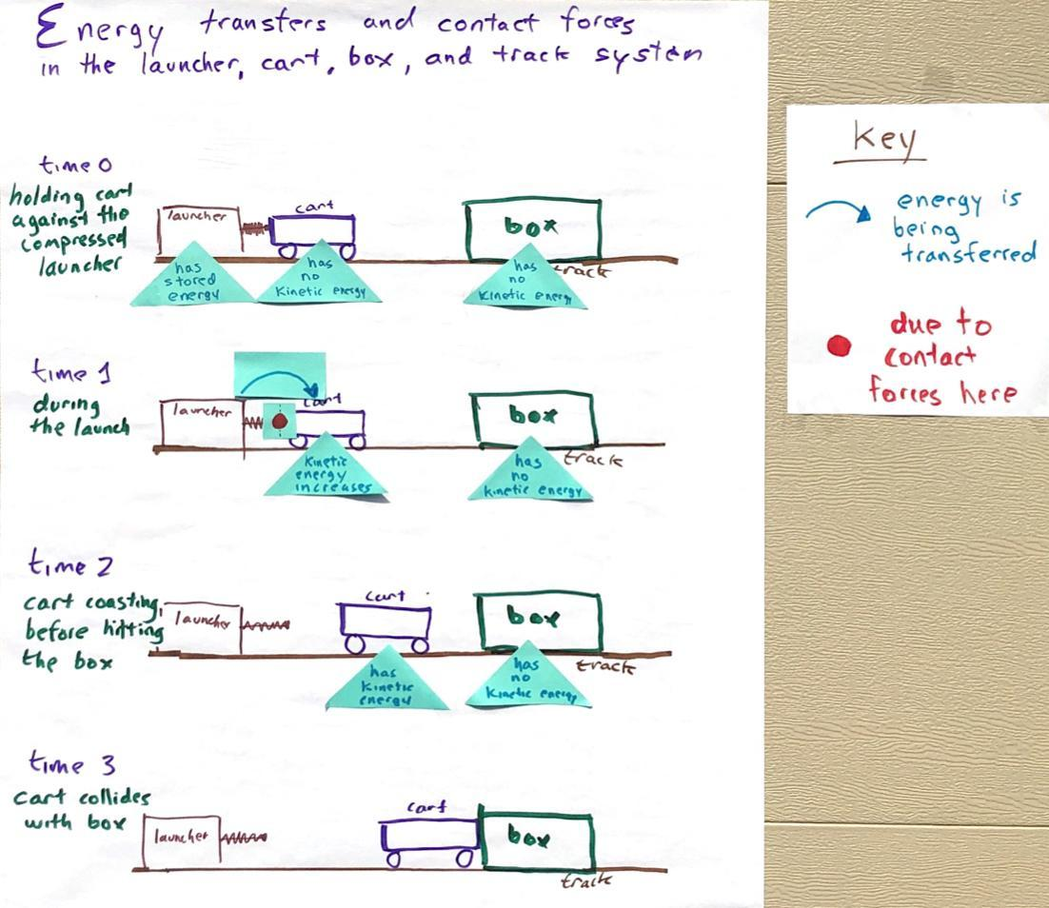  Gather the class in the Scientists Circle. Display slide H. Say, I heard some really great connections being made as groups discussed their explanations. Let’s share and record the relevant ideas we have for revising our previous model we developed for our launcher system. Have students bring their notebooks, colored pencils, and their copies of Energy transfers and contact forces in the launcher, cart, track, and box system.  Display the Energy transfers and contact forces in the launcher, cart, box, and track system poster with the sticky note annotations on it, as shown here. Lead a Building Understandings Discussion to explain what other forces affects the motion and kinetic energy of the cart before a collision.✱ ✱  Ask, Does anyone have an idea to share about where else contact forces cause energy to be transferred between different parts of the launcher system? Listen for these ideas:  - The cart is colliding with air particles, and this causes the cart to slow down and lose kinetic energy.  - The cart is slowing down and losing kinetic energy because of friction between the cart’s wheels and the track.  - The track must gain kinetic energy as increased particle motion (heat) as the cart moves over the track surface.  Ask, If there are collisions between the cart and air particles, what changes about the air particles? Listen for these ideas:  - The air particles gain kinetic energy after collisions with the cart.  - The air particles heat up after collisions with the cart.  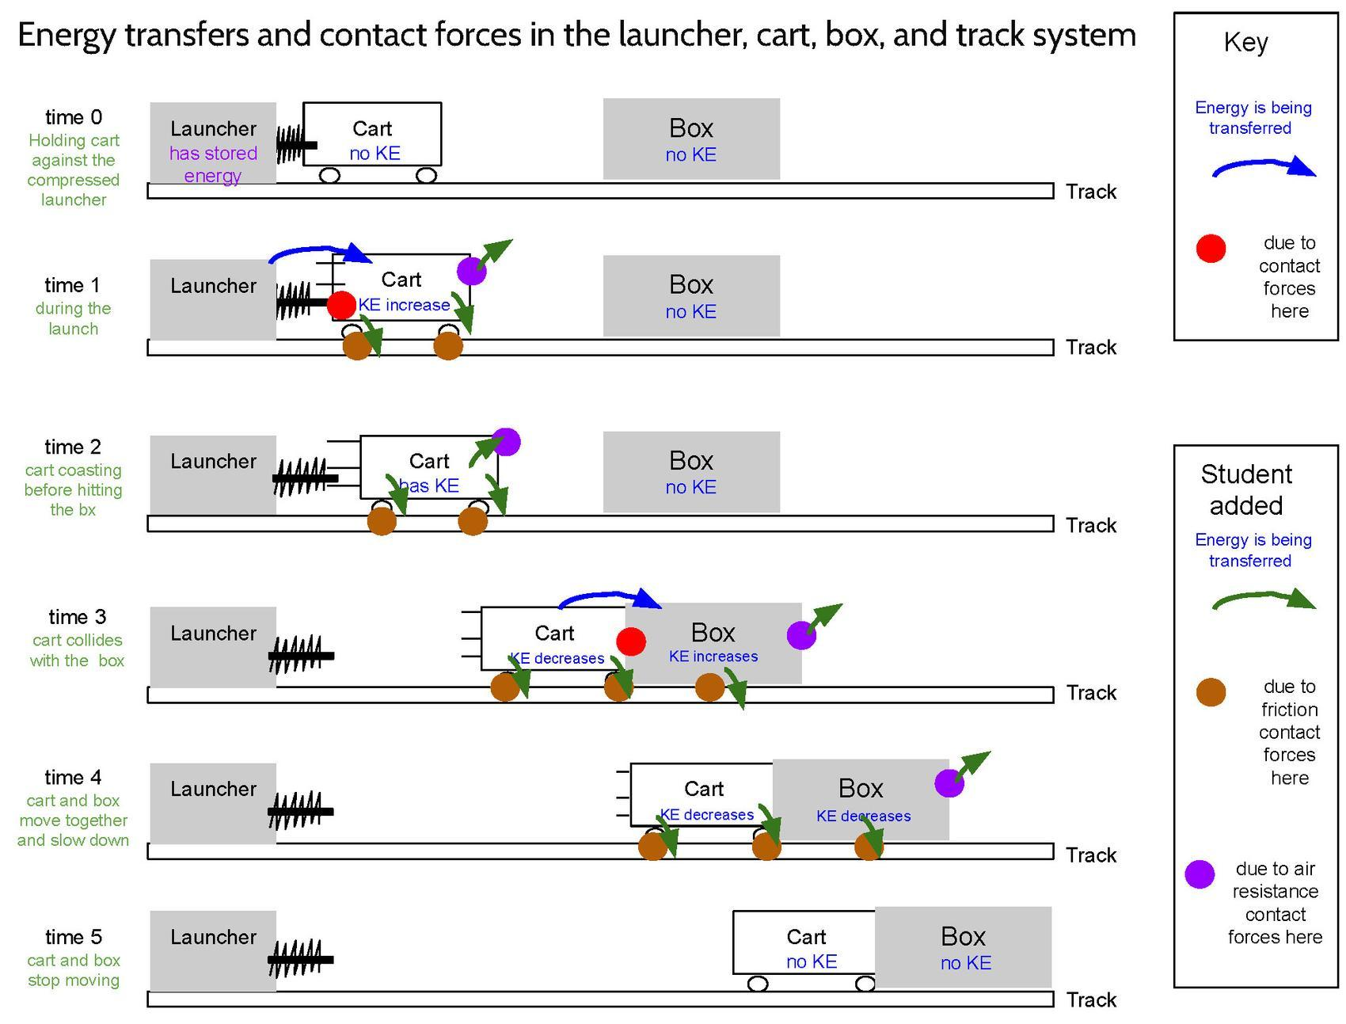  Have students add annotations to their copies of Energy transfers and contact forces in the launcher, cart, track, and box system to represent these ideas. The example diagram shown here provides a key for some of the times and places you may see students adding these annotations to their model.  Display slide I. Say, Let’s update our Progress Trackers with these new ideas. In the Progress Tracker section of your notebook, make a three-part table to record the lesson question, sources of evidence, and what we’ve figured out.  Have students add or move their copies of Energy transfers and contact forces in the launcher, cart, track, and box system to this section of the Progress Tracker. If they can’t because they already glued these into their notebooks, they can add a reference page number to this entry (e.g., “see page X of the notebook”). Encourage students to use the remaining time to add descriptions in words for what they figured out that is represented in the system model we developed as a class. | ✱ SUPPORTING STUDENTS IN ENGAGING IN CONSTRUCTING EXPLANATIONS AND DESIGNING SOLUTIONS  Students have new evidence and reasoning to revise the class collision system model. Specifically, they can indicate areas where forces are occurring due to friction and air resistance. They can also more completely explain energy changes in the model and better explain why the box stops moving after the collision. There is some important foregrounding of ideas for the design challenge in Lesson Set 3 when students discuss how changes in motion and kinetic energy can lessen the severity of a collision.  ✱ SUPPORTING STUDENTS IN DEVELOPING AND USING ENERGY AND MATTER  This modeling activity is helping deepen the understanding that energy is not created or destroyed when you start tracking it into, through, and across systems and subsystems. In their descriptions of energy transfer in the class collision system model they should be able to describe qualitative gains and losses of energy between the subsystems within the cart launcher system model.
  Suggested prompt | Sample student response
  So it sounds like we need to account for these ideas on our model. I heard you say that the cart is colliding with air particles. Where on our model is that happening? | After the cart has been launched when it is traveling toward the box.
  What is happening to the air particles when they collide with the cart? | They heat up and gain kinetic energy.
  Besides the cart, what else is colliding with air particles as it moves? | The box.
  What surface of the box is running into the most air particles? | The front
  Can someone suggest a way for us to represent this in our model? | We could add a red circle on the front of the box at time 4 to show this is where most of the force interaction between the box and the air is occurring. We could add a red circle on the front of the cart at time 2 (and possibly time 1) to show this is where most of the force interaction between the cart and the air is occurring. And we could add blue arrows to show that this is where energy transfer to the air is occurring.
  You also said there were motion and energy changes due to friction. Where are all the places this would be happening in our model? When would this be happening? | After the cart has been launched when it is moving along the track the friction is between the cart’s wheels and the track.
  Can someone suggest a way for us to represent this in our model? | We could add a red circle on the bottom of the box at time 4 (and possibly time 3) to show this is where most of the force interaction between the box and the track is occurring. We could add a red circle on the bottom of the wheels on the cart at time 2 (and possibly time 1) to show this is where most of the force interaction between the cart and the air is occurring. And we could add blue arrows to show that this is where energy transfer to the track is occurring.
  ADDITIONAL GUIDANCE | Students may bring up the idea of static friction by asking about forces between the cart or box and the track when they are not moving. This is OK, and you can ask what students think about forces between surfaces that aren’t moving. You will return to considering net forces in future lessons. Accept all ideas at this time and say, It sounds like we can use this idea of friction to explain why it takes a certain amount of force to get a stationary object to start moving too.

8 · NAVIGATION | 4 min
MATERIALS: Modeling other force interactions in the launcher, cart, box, and track system, colored pencils, Key for modeling force interactions in the launcher, cart, box, and track system
Say, Wow, we have really made progress on our model and filled in a lot of gaps to show what’s happening in the system before, during, and after a collision. We accounted for forces and energy changes when parts of our system are speeding up, slowing down, and colliding. We also figured out a lot about what can contribute to damage in a collision. Let’s take stock of what we know next class and see if we can explain why some objects break or don’t break in a collision.

Introduce the home learning. Say, In preparation for that, look back at the previous models and explanations you developed in the last lesson and consider what you would change about them now in light of what you figured out in this lesson.

Distribute the previously completed copies of Modeling other force interactions in the launcher, cart, box, and track system you collected from students at the end of the last lesson. Show slide J. Emphasize that the revisions that students should make to this handout are a key assessment opportunity for them to demonstrate what they figured out between the first time they completed this handout and now. Tell students that you will collect these next time.✱

ASSESSMENT OPPORTUNITY | Building towards: 9.C Develop and revise a model to identify other parts of the system the cart and box are making contact with or colliding into that are producing contact forces on these subsystems, causing energy to be transferred to or from them as the box and cart travel down the track.  What to look for: See Key for modeling force interactions in the launcher, cart, box, and track system for guidance on what to look for.  What to do: Treat this as a way to measure student growth in understanding from the previous copy you made of their responses at the end of Lesson 8 and the start of Lesson 10. Since you won’t have time to review their revisions until the end of day 1 of the next lesson, make sure you do that at some point during day 2 of the lesson, and definitely before day 3 of the lesson, so you can identify students who would benefit from talking through revisions to their models before working on the transfer task assessment items in Baseball Assessment 1 and Baseball Assessment 2.

ALTERNATE ACTIVITY | Instead of assigning this as home learning, you could use this revision activity as a bell ringer at the start of the next lesson.

